Footnotes and Endnotes
Footnotes and endnotes are separate text storied used in documents and books to show the source of borrowed material or to enter explanatory or supplementary information which does not interrupt the normal reading flow of the document.
Footnotes are typically located at the bottom of a page or beneath text being referenced, and endnotes are typically placed at the end of a document or at the end of a section. If document has been divided up into one or more sections, each section of a document may contain endnotes.
Both footnotes and endnotes consist of two parts:
- A note reference mark in the body text to indicate that additional information is in a footnote or endnote, with a numbering system used for each to tell readers whether to look for the note at the end of the page or the end of the document or section.
- The actual footnote or endnote story content.
[Example: Example of a footnote applied to text in a document:
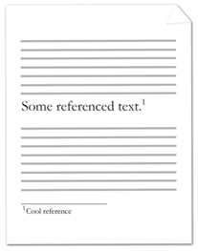
The note reference mark follows the noted text and specifies that there is associated footnote information, and the footnote itself is at the bottom of the current page. end example]
[Example: Consider the following example of an endnote applied to text in a document:
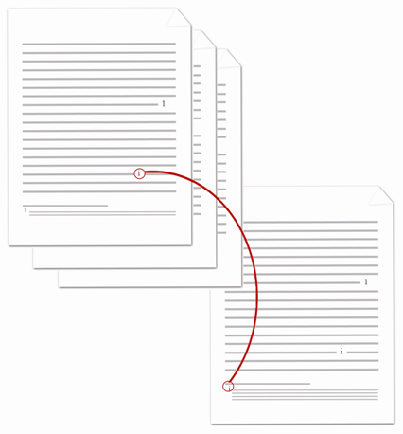
The note reference mark follows the noted text and specifies that there is associated endnote information, and the endnote itself is at the end of the current section. end example]

